CC-215-L: Database Systems Lab
BS(IT) - Fall 2024
LAB – 04
The objective of this lab is to:
- Group functions
- Case and Decode
- Revision
COURSE & LAB INSTRUCTOR: Dr. Asif Sohail
LAB TIMING : 90 MINS
TOTAL MARKS : 45
Task 01: [15 marks]
- Show the average salary for each job title.
SELECT JOB,ROUND(AVG(SAL),2) FROM EMP GROUP BY JOB
- Write an SQL query to display the employee name, salary, and categorize each employee into ‘High Salary’ (salary ≥ 3000), ‘Medium Salary’ (salary between 1500 and 2999), or ‘Low Salary’ (salary less than 1500) using the CASE expression
SELECT ENAME, SAL,
CASE
WHEN SAL >= 3000 THEN 'High Salary'
WHEN SAL BETWEEN 1500 AND 2999 THEN 'Medium Salary'
ELSE 'Low Salary'
END AS Salary_Category
FROM EMP;

- Find out the number of employees under each manager
SELECT MGR,COUNT(*) "Number of Employees" FROM EMP GROUP BY MGR
- Write a query to display the employee names (ENAME) such that each character in the name is repeated twice consecutively.The output should show the original name and the transformed name in two separate columns. For example:
SMITH → SSMMIITTHH
ADAMS → AADDAAMMSS
SELECT ENAME,
SUBSTR(ENAME,1,1)||SUBSTR(ENAME,1,1)||
SUBSTR(ENAME,2,1)||SUBSTR(ENAME,2,1)||
SUBSTR(ENAME,3,1)||SUBSTR(ENAME,3,1)||
SUBSTR(ENAME,4,1)||SUBSTR(ENAME,4,1)||
SUBSTR(ENAME,5,1)||SUBSTR(ENAME,5,1) ||
SUBSTR(ENAME,6,1)||SUBSTR(ENAME,6,1) AS DOUBLED_NAME
FROM EMP

- Write an SQL query to display the employee name, job, and calculate a bonus using the CASE expression. The bonus should be 15% of salary for MANAGER, 10% for SALESMAN, 5% for CLERK, and 20% for all other jobs.
SELECT ENAME, JOB, CASE JOB WHEN 'MANAGER' THEN SAL * 0.15 WHEN 'SALESMAN' THEN SAL * 0.10 WHEN 'CLERK' THEN SAL * 0.05 ELSE SAL * 0.20 END AS BONUS FROM EMP;
- Write an SQL query to display the employee name along with the department name instead of department number, Map department numbers to names:
10 → ACCOUNTING
20 → RESEARCH
30 → SALES
others → OTHERS.
SELECT ENAME,
DECODE(DEPTNO,
10, 'ACCOUNTING',
20, 'RESEARCH',
30, 'SALES',
'OTHERS') AS DEPARTMENT,
DEPTNO
FROM EMP;

- Write a query to display the student names (STD_NAME) from the PUCIT table such that the case of each character is toggled:
SELECT STD_NAME,
TRANSLATE(STD_NAME,
'ABCDEFGHIJKLMNOPQRSTUVWXYZabcdefghijklmnopqrstuvwxyz',
'abcdefghijklmnopqrstuvwxyzABCDEFGHIJKLMNOPQRSTUVWXYZ') AS TOGGLED_NAME
FROM PUCIT;
- Write an SQL query to display the employee name and the year in which they were hired.
SELECT ENAME, EXTRACT(YEAR FROM HIREDATE) FROM EMP
- Write an SQL query to display the department number and the maximum salary of employees in each department. Only include those departments where the maximum salary is greater than 3000.
SELECT DEPTNO,MAX(SAL) "MAX SALARY" FROM EMP GROUP BY DEPTNO HAVING MAX(SAL) > 3000
- Each employee saves 10% of their salary every month. Write a query to calculate the number of months required for each employee to save a total of $2,500. The output should display the employee name, salary, and the number of months needed. Round up fractional months to the next whole month.
SELECT ENAME,
SAL,
CEIL(2500 / (SAL * 0.1)) AS MONTHS_REQUIRED
FROM EMP;

Task 02: [20 marks]
- Show output in the following format:
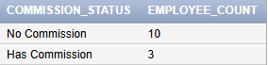
SELECT
CASE
WHEN COMM IS NULL OR COMM = 0 THEN 'NO COMMISSION'
ELSE 'HAS COMMISSION'
END AS COMMISSION_STATUS,
COUNT(*) AS EMPLOYEE_COUNT
FROM EMP
GROUP BY
CASE
WHEN COMM IS NULL OR COMM = 0 THEN 'NO COMMISSION'
ELSE 'HAS COMMISSION'
END;

- Display the names of the employees reversed in a separate column.
SELECT ENAME, REVERSE(ENAME) AS REVERSED_ENAME FROM EMP
OR
SELECT ENAME, SUBSTR(ENAME,-1,1) || SUBSTR(ENAME,-2,1) || SUBSTR(ENAME,-3,1) || SUBSTR(ENAME,-4,1) || SUBSTR(ENAME,-5,1) || SUBSTR(ENAME,-6,1) AS REVERSED_ENAME FROM EMP
- Display the amount remaining of each department after paying all expenses [The total salaries of all employees of that department]. The department no 10,20 receives 15,000. The department no 20,40 receives 17,000.
SELECT DEPTNO,
DECODE(DEPTNO,
10, 15000,
20, 15000,
30, 17000,
40, 17000)
- SUM(SAL) AS REMAINING_AMOUNT
FROM EMP
GROUP BY DEPTNO;
- Display the total salary paid in each department for every job type.(Don’t display subtotal and total)
SELECT DEPTNO,
JOB,
SUM(SAL) AS TOTAL_SALARY
FROM EMP
GROUP BY DEPTNO, JOB
ORDER BY DEPTNO, JOB;

- Find jobs with more than 2 employees and list their details.
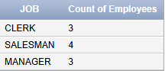
SELECT JOB, COUNT(*) "Count of Employees" FROM EMP GROUP BY JOB HAVING COUNT(*) > 2
- Show average salary by job within each department, average per department, and overall average.
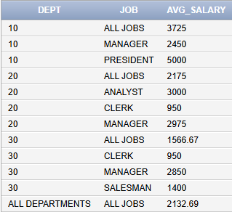
SELECT NVL(TO_CHAR(DEPTNO), 'ALL DEPARTMENTS') DEPT,
NVL(JOB,'ALL JOBS') JOB,
ROUND(AVG(SAL),2) AS AVG_SALARY
FROM EMP
GROUP BY ROLLUP(DEPTNO, JOB)
ORDER BY DEPTNO, JOB;

- Show average salary by department and job, plus average in each department, each job and overall average
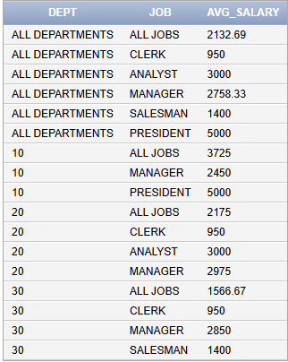
SELECT NVL(TO_CHAR(DEPTNO), 'ALL DEPARTMENTS') DEPT,
NVL(JOB,'ALL JOBS') JOB,
ROUND(AVG(SAL),2) AS AVG_SALARY
FROM EMP
GROUP BY CUBE(DEPTNO, JOB)

- Summarize a report that displays each department along with all the associated jobs and the total salary earned for each department.
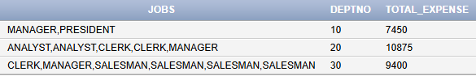
SELECT LISTAGG(JOB, ',') WITHIN GROUP(ORDER BY JOB) AS JOBS, DEPTNO, SUM(SAL) TOTAL_EXPENSE FROM EMP GROUP BY DEPTNO
- Write a query to display the average commission of all employees, treating employees with no commission (NULL) as having zero
SELECT ROUND(AVG(NVL(COMM,0) ),2) AS AVG_COMM FROM EMP
- Write a query to display the total salary expense grouped by job and by department. If the job is not specified, display ‘ALL JOBS’, and if the department number is not specified, display ‘ALL DEPARTMENTS’
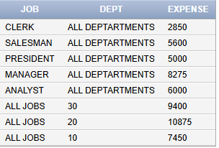
SELECT NVL(JOB, 'ALL JOBS') JOB, NVL(TO_CHAR(DEPTNO),'ALL DEPTARTMENTS') DEPT, SUM(SAL) EXPENSE FROM EMP GROUP BY GROUPING SETS(JOB, DEPTNO)

Task 03: [9 marks]

- For each department, display:
- Department number
- Total salary expense
- Average salary of that department
- The difference between department’s average salary and 2133 (formatted as +value or -value), If it is more than 2133 use + sign if less than - otherwise 0.
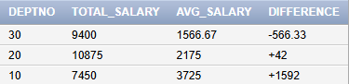
SELECT DEPTNO,
SUM(SAL) AS TOTAL_SALARY,
ROUND(AVG(SAL),2) AS AVG_SALARY,
CASE
WHEN AVG(SAL) > 2133
THEN '+' || TO_CHAR(ROUND(AVG(SAL) - 2133,2))
WHEN AVG(SAL) < 2133
THEN '-' || TO_CHAR(ROUND(2133 - AVG(SAL),2))
ELSE '0'
END AS DIFFERENCE
FROM EMP
GROUP BY DEPTNO;

- Display empno, ename, job, sal, tax, net sal. The tax is computed using the following tax slabs
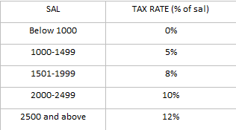
select empno, ename, job, sal,
case
when sal < 1000 then 0
when sal between 1000 and 1499 then sal*0.05
when sal between 1500 and 1999 then sal*0.08
when sal between 2000 and 2499 then sal*0.1
else sal*0.12 end as "Tax Rate" ,
case
when sal < 1000 then to_char(sal)
when sal between 1000 and 1499 then to_char(sal-(sal*(0.05)))
when sal between 1500 and 1999 then to_char(sal-(sal*(0.08)))
when sal between 2000 and 2499 then to_char(sal-(sal*(0.1)))
else to_char(sal-(sal*(0.12))) end as "Net Sal"

from emp;
- The company wants to analyze salary expenses based on job categories and departments. Classify jobs into the following categories:
- All jobs starting with ‘M’ → ‘MANAGEMENT’
- All jobs starting with ‘S’ → ‘SUPPORT’
- All other jobs → ‘GENERAL’
For each department and job category, display the total salary expense. Also include subtotal rows for each department (across all job categories) and a final grand total row.
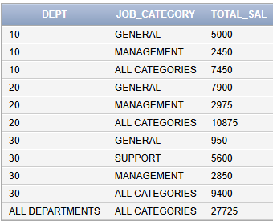
SELECT NVL(TO_CHAR(DEPTNO), 'ALL DEPARTMENTS') AS DEPT,
NVL( CASE
WHEN SUBSTR(JOB,1,1) = 'M' THEN 'MANAGEMENT'
WHEN SUBSTR(JOB,1,1) = 'S' THEN 'SUPPORT'
ELSE 'GENERAL'
END
,'ALL CATEGORIES') JOB_CATEGORY,
SUM(SAL) AS TOTAL_SAL
FROM EMP
GROUP BY ROLLUP(
DEPTNO,
CASE
WHEN SUBSTR(JOB,1,1) = 'M' THEN 'MANAGEMENT'
WHEN SUBSTR(JOB,1,1) = 'S' THEN 'SUPPORT'
ELSE 'GENERAL'
END);

Task 04: [6 marks]
VIVA VOCE

